Nama : Krishna Yoga Mahendra

NIM : 6701220116

Kelas : D3SI4604

1.

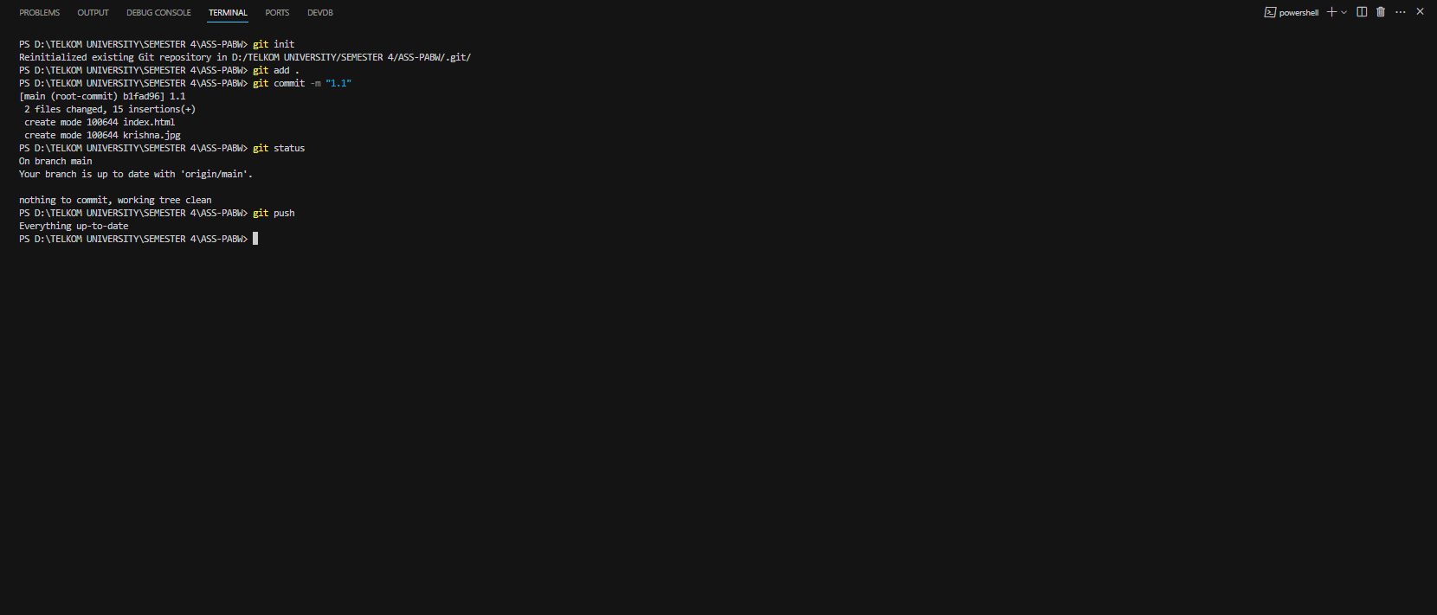

2.1

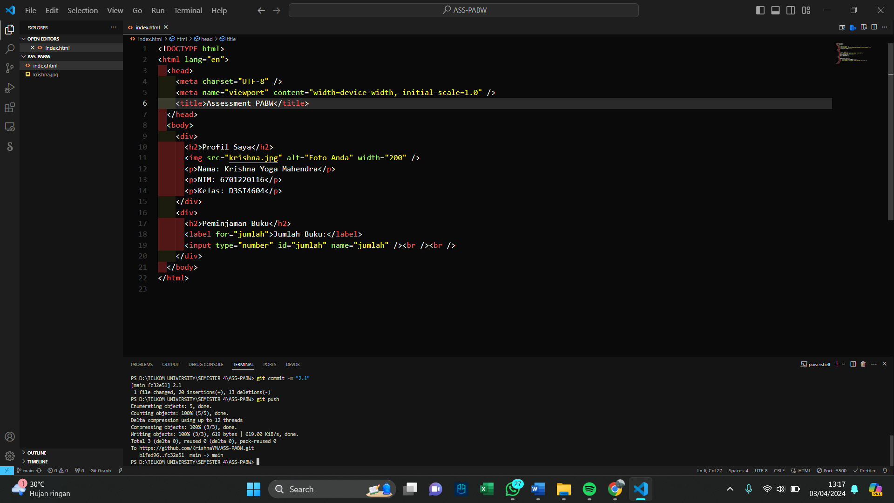

2.2

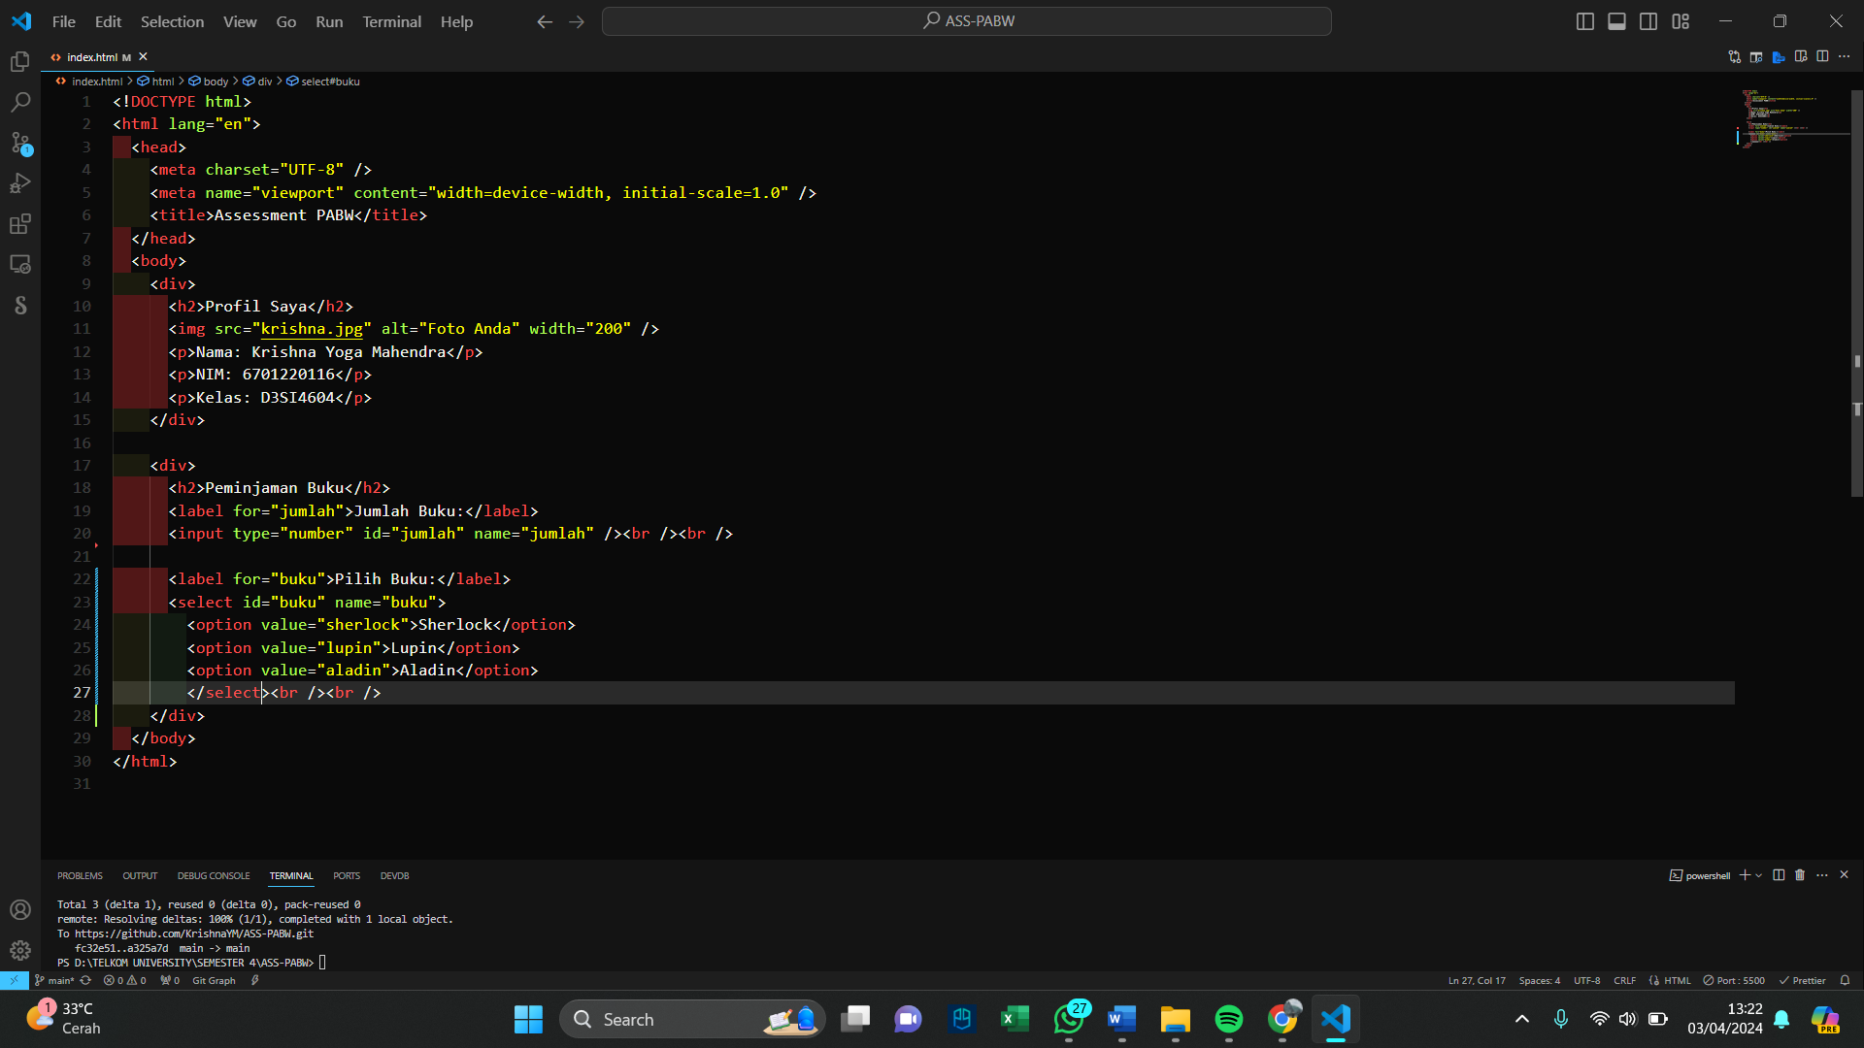

2.3

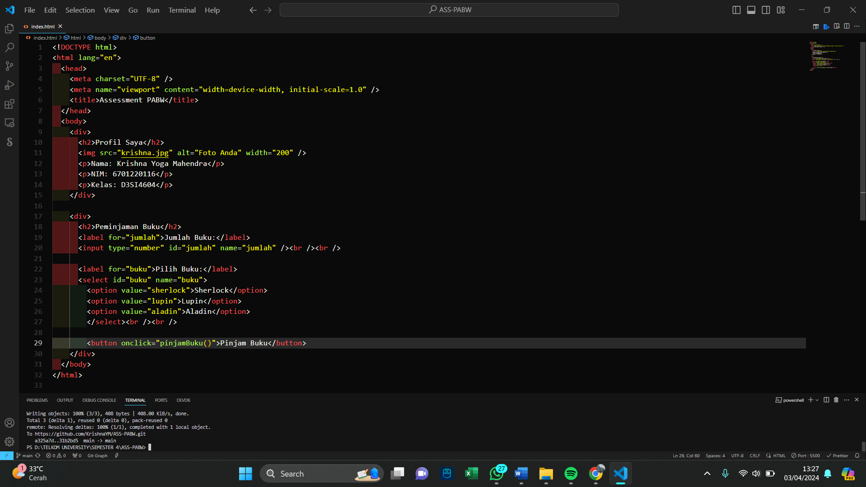

3

4

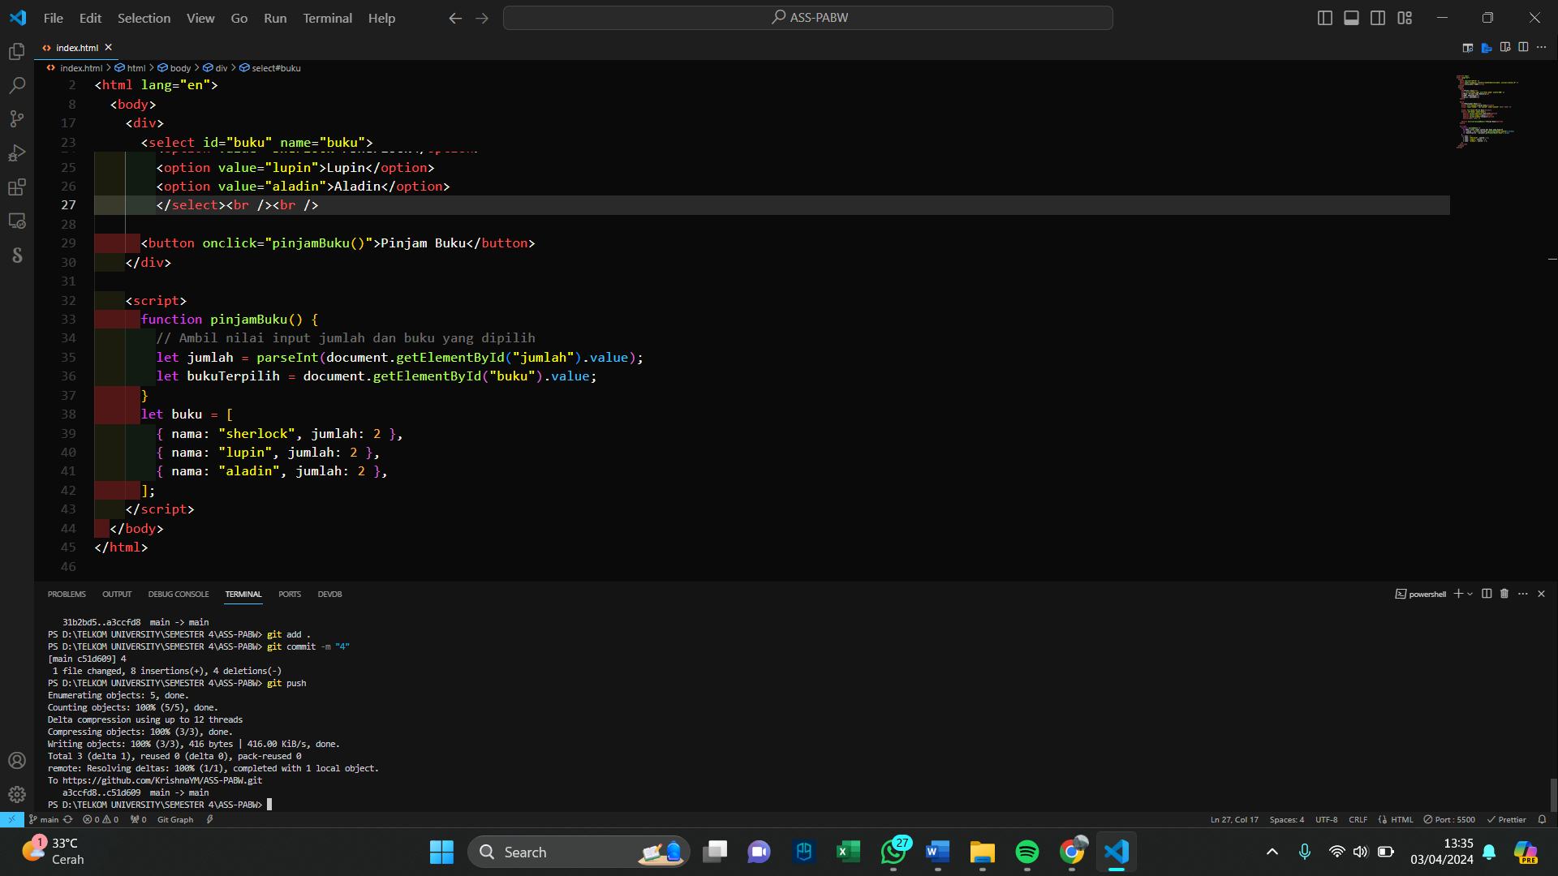

5

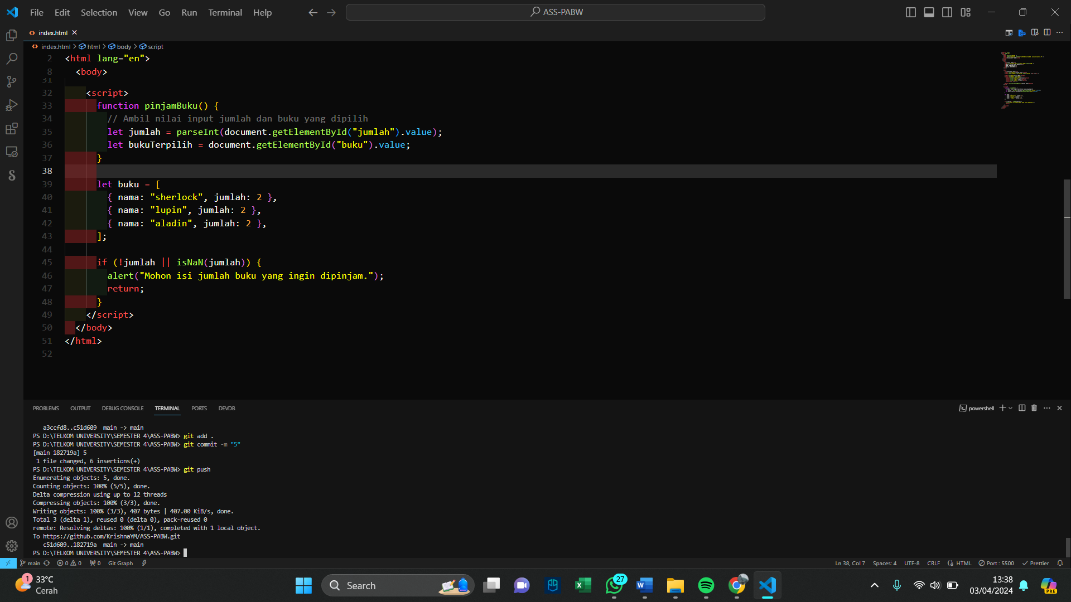

6

7

8

